# CS 255 System Design Document Template

Jose Munoz

## UML Diagrams

### UML Use Case Diagram

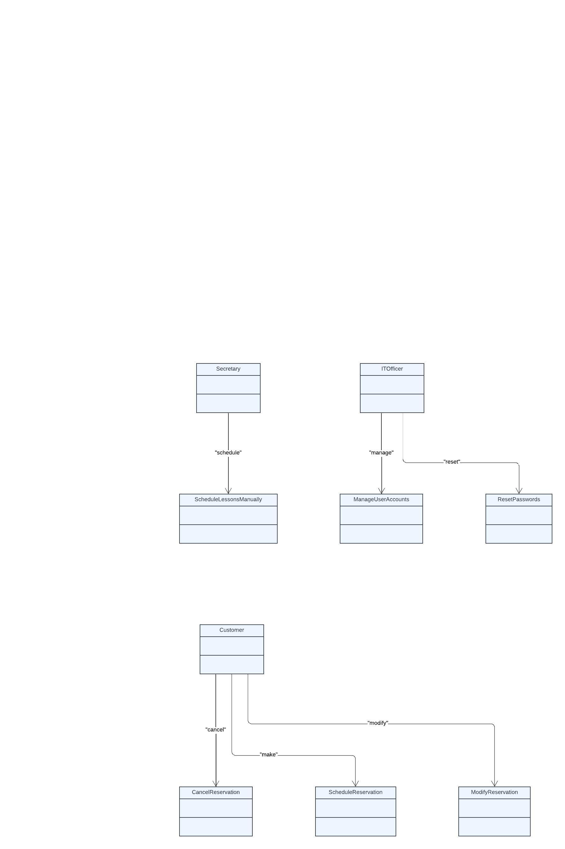

### UML Activity Diagrams

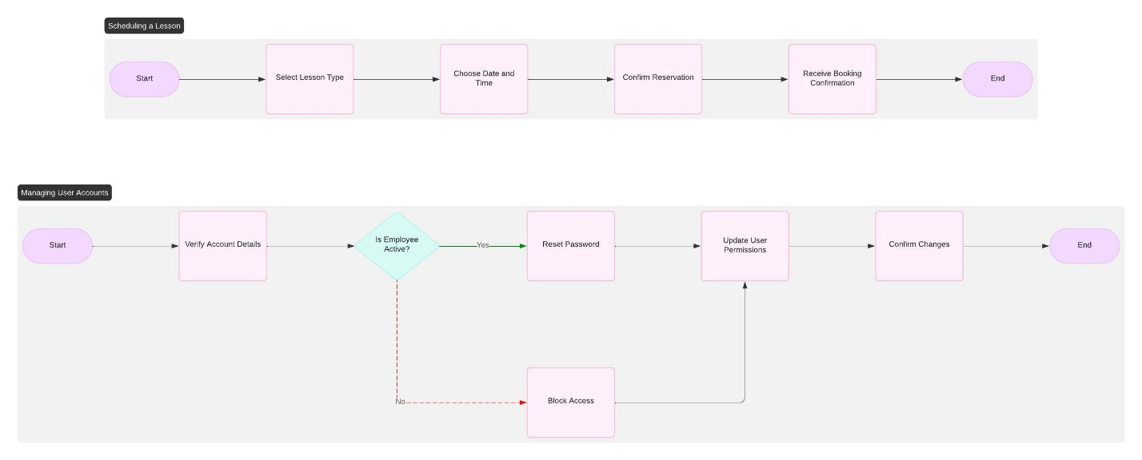

### UML Sequence Diagram

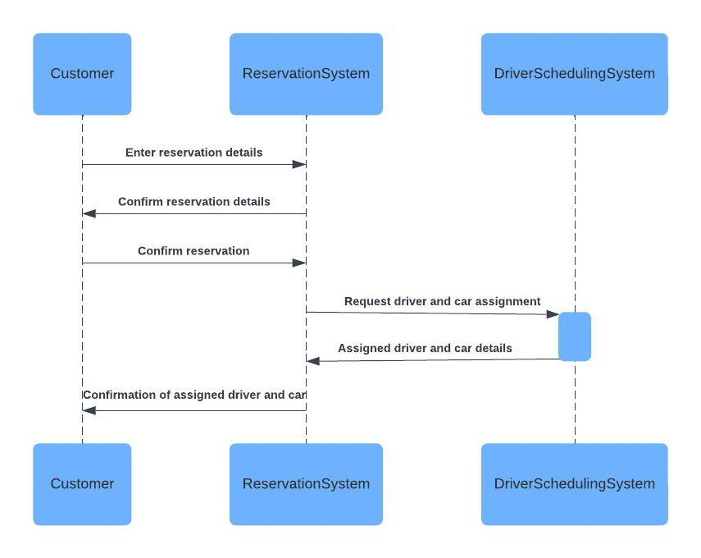

### UML Class Diagram

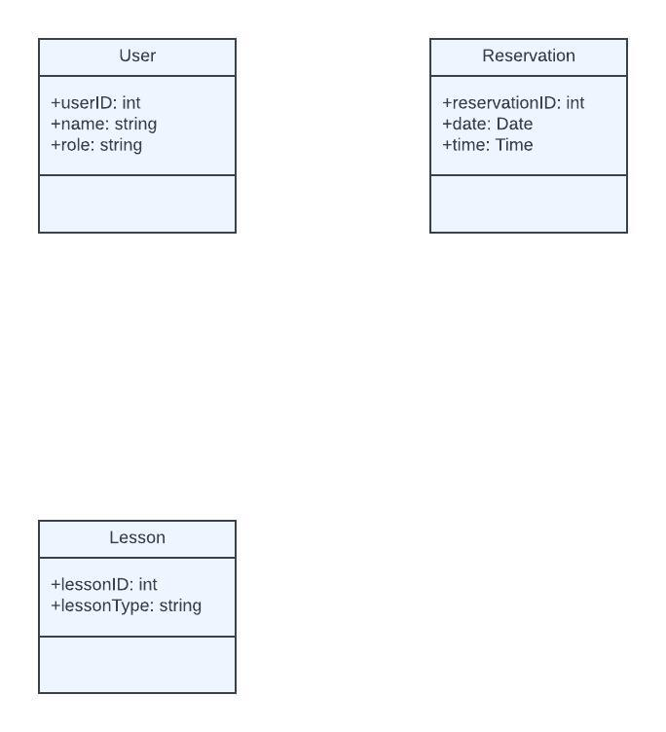

## Technical Requirements

**Hardware**: Cloud-based servers for data storage and processing, accessible by both customers and employees remotely.

**Software**: Secure web application accessible on mobile and desktop browsers.

**Tools**: User management tools for account creation and access control, as well as reporting tools for activity tracking.

**Infrastructure**: Role-based access control, secure internet connection for data transmission, and backup and recovery system in place for data security.